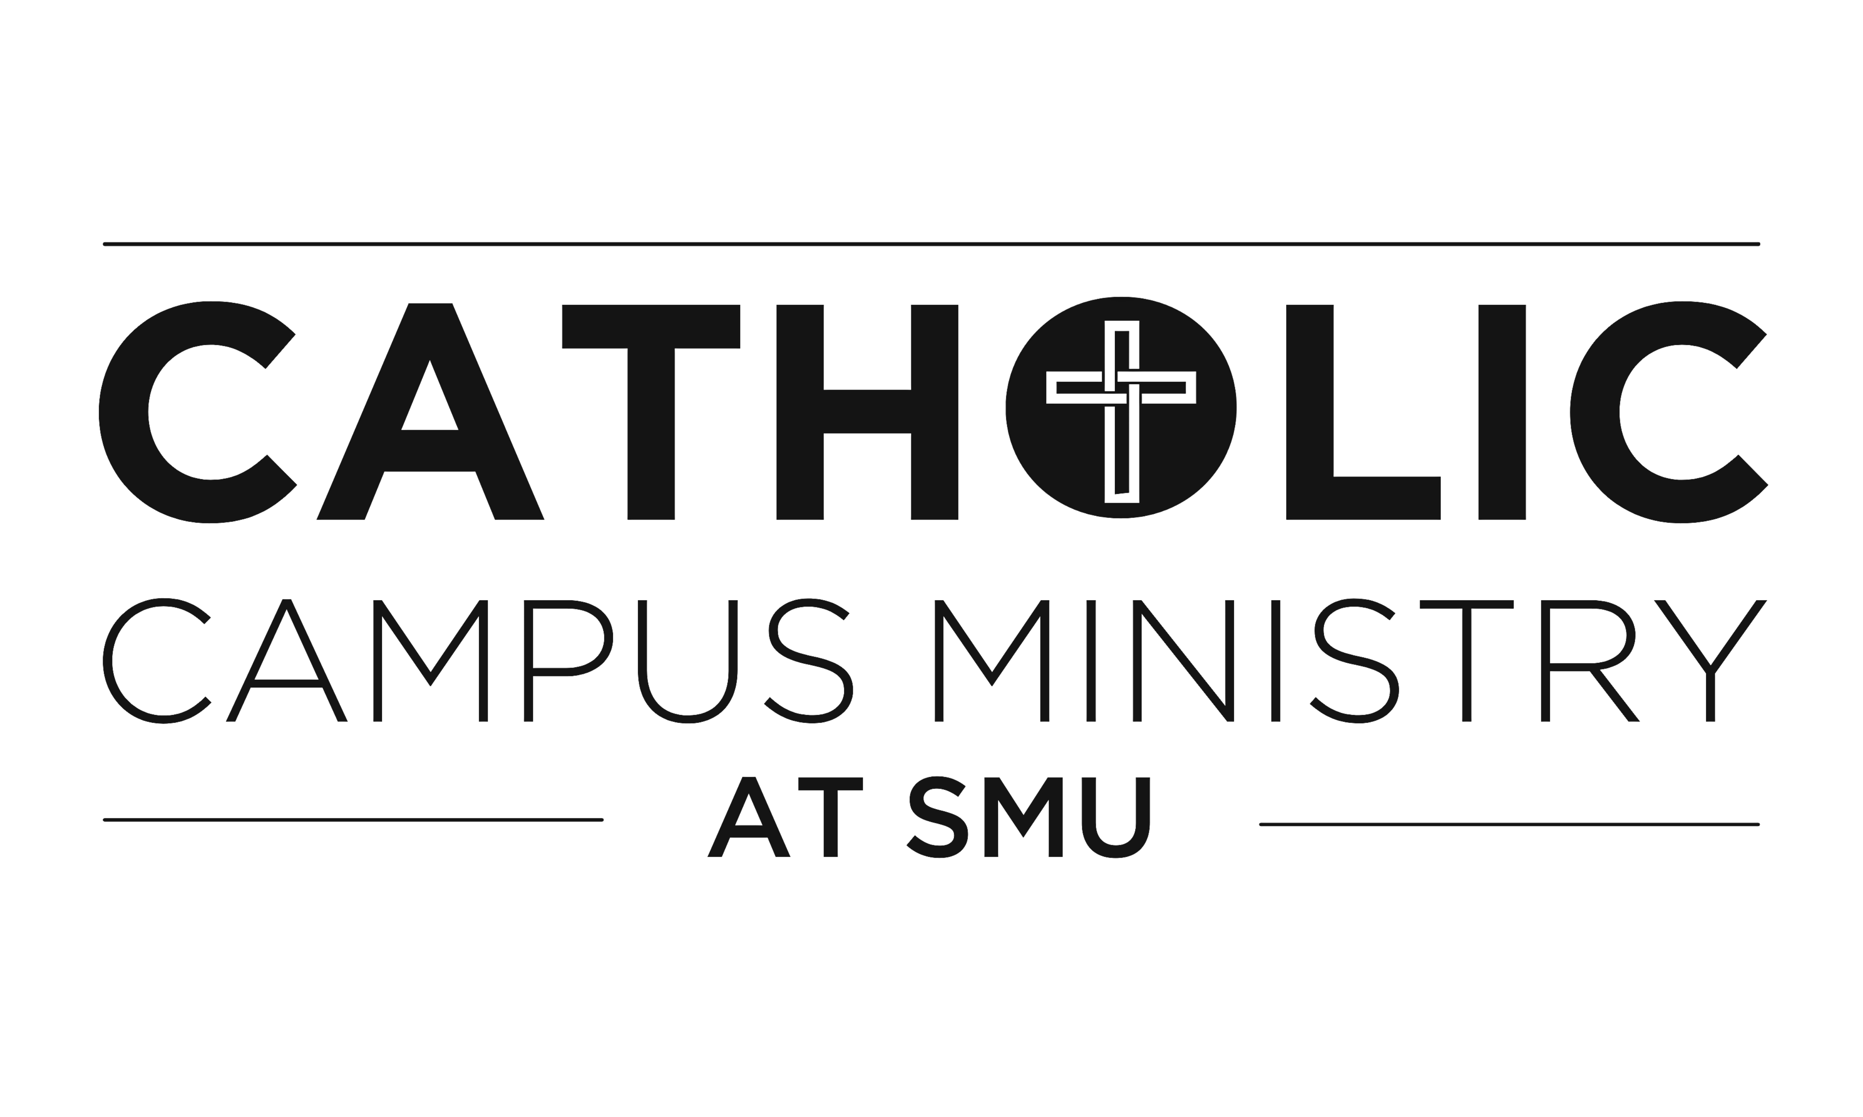
2024-2025 Servant Leadership Council Application
Catholic Campus Ministry at SMU is a home for forming servant leaders through an
intentional and personal relationship with Jesus Christ through His Church.

Please return to Margaret by email at mabruzzo@smu.edu or at the Catholic Center by Thursday, February 29th.

Thank you for your interest in the Servant Leadership Council! Please spend time in prayer and conversation about how you might best serve our community, and reach out if it would be helpful to talk with us. We value your commitment to the mission of Catholic Campus Ministry!

Name:
Email: Cell:
Graduation Year: Major(s)/Minor(s):

SLC is a year-long commitment through May 2025. Please list any other commitments or leadership roles (please include average weekly hours).

Academics:

Extracurriculars:

Work:

Hobbies/Other Activities:

How much time do you think you can devote to an SLC role?

SLC seeks to form students into servant leaders. SLC members must be practicing Catholic students who are committed to growing in the Catholic faith. They should be eager to develop the attitudes and skills of servant leaders and be ready to take responsibility for their ministry.

All members of SLC commit to:
- A daily prayer life, regular attendance at Sunday Mass, and regular confession
- Witnessing to the truth of the Catholic faith in your life and words
- Fostering authentic relationships with others at the C and on campus
- Striving to grow in the faith and servant leadership through ongoing formation
- Striving to grow in virtue, especially in the areas of chastity, sobriety, and excellence
- Actively participating in your meetings with the campus minister or chaplain
- Actively participating in all monthly SLC meetings and Leadership Summit
- Providing timely updates about your ministry to the SLC and campus minister
- Participating in Sunday Supper and Wednesday Night Ministry (if your schedule does not allow it, please discuss a plan of alternative involvement with campus minister)
- Attending at least one Service Saturday each semester
- Supporting other SLC leaders by volunteering for at least one other event per semester
- Following all ministry or diocesan policies, including Safe Environment and driving policies
- Putting forth the time needed to meet your responsibilities

Roles & Responsibilities
SLC President
The SLC president is an SLC member who fellow SLC members elect to serve as the SLC “team captain.” S/he encourages, energizes, and empowers the chairs to engage in outreach and carry out their roles. The SLC president should have been on SLC at least a year. You would:
- Collaborate with the ministry staff on the mission and direction of SLC
- Help plan and lead regular SLC meetings, including the Leadership Summit(s)
- Help keep SLC members accountable for their responsibilities

SLC Treasurer
The SLC treasurer is an SLC member elected by fellow SLC members. You would:
- Serve as the student organization treasurer and as a liaison to the Student Senate
- Assist with preparation of Senate budgets, process reimbursement paperwork with the Student Senate, and attend Senate meetings to request funds

Service
The Service Chair seeks to foster a passion for service. You would:
- Recruit students to participate in Catholic Campus Ministry at SMU service events
- Plan regular service activities (particularly Service Saturdays) with campus minister: identify and schedule service opportunities, recruit student volunteers, recruit volunteer drivers, maintain records, and serve as point person
- Build relationships with on-campus groups such as Mustang Heroes and Mustangs for Life, and, when appropriate, facilitate CCM involvement in their service events
Community Building
The Community Building Chair/SLC Treasurer promotes community and a sense of belonging at the C. You would:
- Develop a vision and strategy for building community, ensuring that events foster community and belonging
- Plan, promote, and execute community-building events (i.e., Back-to-School BBQ, SMUCUS, Mardi Gras, etc.)
- Recruit and organize additional student volunteers
- Organize groups to attend/participate together in campus events and informal activities

FYSH (First-Year Student Homes)
FYSH welcomes and draws first-year students into our community at the C and aims to help them integrate into our community and grow spiritually. FYSH leaders can be sophomores or juniors. You would:
- Form authentic relationships with members of their FYSH group
- Help first-years integrate into community-wide events such as Mass, Sunday Supper, Mustang Awakening, Wednesday Night Ministry, and Jericho
- Participate in outreach events such as Night at the Club and the Back to School BBQ
- Assist in special freshman outreach/community-building nights
- Prepare for, lead, and present at weekly FYSH Bible Study during the Spring semester

Catholic Hispanic Association (CHACHA)
CHACHA builds community among students from Latin American cultures, encourages the faith of native Spanish speakers, and fosters a deeper appreciation for Hispanic Catholicism among all students. You would:
- Recruit and schedule Spanish-language lectors
- Plan and host meal for monthly Misa y Comida
- Engage in outreach to native Spanish speakers who might not otherwise come to the C
- Work with the campus minister to develop, plan, and host activities that will promote community and deepen students’ faith (such as celebrations for Día de Los Muertos, Nuestra Señora de Guadalupe)
- Work with campus minister and fellow SLC leaders to develop stronger connections between native-English and native-Spanish speaking students

Mustang Awakening Retreat Chairs
Mustang Awakening chairs plan, coordinate, and execute this student-led retreat. You would:
- Help Campus Minister plan the retreat, including: help choose a theme, recruit and help train student staff, plan talks, coordinate retreat schedule, assist with logistics of retreat
- Participate in weekly meetings with ministry staff
- Do planning with campus minister during spring/summer months before the retreat

Liturgy
The Liturgy Chairs help others grow in their relationship with Christ and the Church through liturgical worship. You would:
- Help prepare for Sunday and Holy Day Masses and prepare/plan for liturgical seasons
- Serve as and/or recruit and train sacristans for Sunday and daily Masses
- Recruit, train, and schedule students for liturgical ministry (ushers, sacristans, lectors, altar servers, and extraordinary ministers of Holy Communion)
- Will be trained as an EMHC, lector, sacristan, and usher

Wednesday Night Ministry/Women’s and Men’s Ministry
WNM Chairs seek to build a community focused on growing in a deeper relationship with Christ, particularly through spiritual, moral, intellectual, and human formation. You would:
- Help Campus Minister prepare, plan, and execute Wednesday Night Ministry events
- Lead small discussion groups and recruit leaders (as needed)
- Help students who want to get involved by connecting them with people and ministries
- Develop and execute plans for additional men’s and women’s events

Please list your top three preferences for areas to serve: (NB: We consider your preferences, but campus ministry staff ultimately will select leaders through prayerful discernment of where students’ gifts and desires best fit the community’s needs.)

Preference #1:
Preference #2:
Preference #3:
Are you open to serving as the SLC president (in addition to your other role)?
Are you open to serving as the SLC treasurer (in addition to your other role)?

Application Questionnaire
Why are you applying for the Servant Leadership Council?

How do your gifts, talents, and passions line up with the areas in which you feel called to serve?

What past experiences might help you in serving in this capacity? Where do you see opportunities for personal growth in this position?

Do you have any reservations or concerns about meeting the commitments that are expected of members of SLC?

Do you have a daily prayer life? What does it involve? How consistent are you in the responsibilities of your faith (attending Sunday Mass, going to Confession, etc.) How do you want to grow in your faith?

Is there anything else you would like us to know about you?

I have spent time in prayer discerning where I am being called to share my gifts and passions with my fellow students. If offered a position, I commit to carrying out all the responsibilities required by these positions.

Signed Date

